

**Green University of Bangladesh**

**Department of Computer Science and Engineering (CSE)**

**Faculty of Sciences and Engineering**

**Semester: (Spring, Year:2022), B.Sc. in CSE (Day)**

**Course Title: Operating System Lab**

**Course Code: CSE 310 Section: 201+202 EE**

**Lab Project Name: Green Library Management System**

**Student Details**

|  |  |  |  |
| --- | --- | --- | --- |
| **Name** | | **ID** | **Contribution** |
| **1.** | MD Shahrior Shawon Prio | 192002032 | 50% |
| **2.** | Sumon Shardar | 202015017 | 50% |
| **3.** |  |  |  |

**Submission Date : 07/05/2021**

**Course Teacher’s Name : Md. Mamunur Rahman**

|  |
| --- |
| **Lab Project Status**  **Marks: ………………………………… Signature: .....................**  **Comments: .............................................. Date: ..............................** |

Table of Contents

Chapter 1 Introduction 3

1.1 Introduction 3

1.2 Objective 3

Chapter 2 Design/Development/Implementation of the Project 4

2.1 Design/Implementation 4

Chapter 3 Performance Evaluation 5

3.1 Results and Discussions 5

Chapter 4 Conclusion 6

4.1 Introduction 6

4.1 Practical Implications 6

4.2 Scope of Future Work 6

References 7

# Chapter 1 Introduction

## Introduction

In our Operating System lab, we must create a project based on our lab learning. A group of two people must contribute and create the project. In our group we are two members, me and my group member wanted to make project which can help Green University library management.

## Objective

Our objective or goal is same as the app name is. In this online education era an easy library management system will help authority to monitor the books and library managements easy and smooth.

# Chapter 2

# Implementation of the Project

## Design:

* + 1. **Methodology:**

The system is an automated Library Management System. Through our software user can add books, search books, view books, update information, edit information, add student information, find student information in quick time. Our proposed system has the following advantages.

1. User friendly interface
2. Fast access to database
3. Less error
4. More Storage Capacity
5. Search facility
6. Look and Feel Environment
7. Quick transaction

All the manual difficulties in managing the library have been rectified by implementing computerization.

* + 1. **Tools and Techniques:**

Tools:

Fresh Computer

Oracle virtual machine installed

Techniques:

Linux

Shell Language

**2.1.3: Setting up the environment:**

**2.1.4: WELCOME:**

**2.1.5: Choosing the Menu:**

**2.1.6: Adding New Books:**

**2.1.7 View Books:**

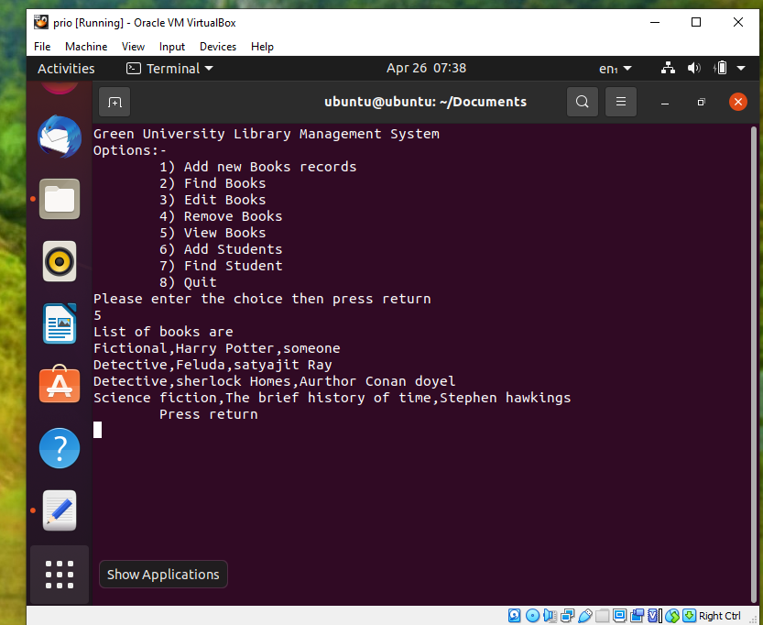

**2.1.8 Finding books:**

**2.1.8 Editing the books:**

**2.1.9 Removing the books:**

**2.1.10 Adding Students:**

**2.1.11 Finding Students:**

**2.1.12 Quit:**

# Chapter 3

## Performance Evaluation:

We create the shell files following the lab learnings. Then we had to add the shell scripts files. After writing the scripts we have to go through the Oracle VirtualBox to run the program. It is very complicated and quite tough to run VirtualBox in our low-end pc. But somehow the issue we faced was sorted out and we were able run the project exactly as we wanted.

## Results and Discussions

* + 1. **Results:**

While creating shell files we find it easy and very interesting. After when we started compiling the program successfully installed. After Installation process is done, we started to run the program. Well now when the application starts while doing it showed the welcome page and other functionalities like add book, find book etc worked perfectly.

# Conclusion

## Introduction

While implementing the project we faced some issue on Oracle Virtual machine cause sometimes it doesn’t work properly on low end PC. But we were able to successfully complete the project and it runs smoothly.

## Practical Implications

This is a written program in shell. It will help the authority to monitor the student activity as well as

the book records.

**Scope of Future Work:**

## This creates an opportunity for the future. The world is updating everyday and for some modern problems require some modern solution. Me and my teammate has a plan to implement the app to help the system in near future.

# References

<https://techvidvan.com/>

https://projectworlds.in/

<https://replit.com/>

<https://www.youtube.com/>